Simplifed Metada Repository for Interoperability

in Heterogen Environment

February 22, 2020

Contents

|  |  |  |  |  |
| --- | --- | --- | --- | --- |
| 1 | Introduction | | | 6 |
|  | 1.1 | Background . . . . . . . . . . . . . . . . . . . . . . . . . . . . . . | | 6 |
|  | 1.2 | Problem Statements . . . . . . . . . . . . . . . . . . . . . . . . . | | 7 |
|  | 1.3 | Scope | ................................. | 7 |
|  | 1.4 | Methodology . . . . . . . . . . . . . . . . . . . . . . . . . . . . . | | 8 |
| 2 | Literature Review | | | 9 |
|  | 2.1 | Distributed and Heterogen System . . . . . . . . . . . . . . . . . | | 9 |
|  | 2.2 | Metadata Repository . . . . . . . . . . . . . . . . . . . . . . . . . | | 12 |
|  | 2.3 | Business Process Modelling Notation . . . . . . . . . . . . . . . . | | 13 |
|  | 2.4 | IDEF | ................................. | 13 |
|  |  | 2.4.1 | IDEF Definition . . . . . . . . . . . . . . . . . . . . . . . . . | 13 |
|  |  | 2.4.2 | IDEF 0 Modeling Functions . . . . . . . . . . . . . . . . | 14 |
|  | 2.5 | XSD | ................................. | 15 |
| 3 System Specification and Design | | | | 17 |
|  | 3.1 | Stakeholder Analysis and User Model . . . . . . . . . . . . . . . | | 17 |
|  |  | 3.1.1 | Stakeholder Analysis (Matrix) . . . . . . . . . . . . . . . . | 17 |
|  |  | 3.1.2 | User Case Metadata Repository . . . . . . . . . . . . . . . | 17 |
|  | 3.2 | Business Process . . . . . . . . . . . . . . . . . . . . . . . . . . . | | 17 |
|  |  | 3.2.1 | Implementation Stage . . . . . . . . . . . . . . . . . . . . | 17 |
|  |  | 3.2.2 | System Adoption Planning . . . . . . . . . . . . . . . . . | 20 |
|  | 3.3 | Data Model . . . . . . . . . . . . . . . . . . . . . . . . . . . . . . | | 20 |
|  | 3.4 | Functional Specification . . . . . . . . . . . . . . . . . . . . . . . | | 21 |
|  | 3.5 | Interaction Specification . . . . . . . . . . . . . . . . . . . . . . . | | 24 |
| 4 | Implementation | | | 29 |
|  | 4.1 | System Design . . . . . . . . . . . . . . . . . . . . . . . . . . . . | | 29 |
|  |  | 4.1.1 | Login Mechanism . . . . . . . . . . . . . . . . . . . . . . . | 29 |
|  |  | 4.1.2 | User Page . . . . . . . . . . . . . . . . . . . . . . . . . . . | 29 |
|  |  | 4.1.3 | Role Page . . . . . . . . . . . . . . . . . . . . . . . . . . . | 29 |
|  |  | 4.1.4 | SIM Page . . . . . . . . . . . . . . . . . . . . . . . . . . . | 29 |
|  |  | 4.1.5 | Database Page . . . . . . . . . . . . . . . . . . . . . . . . | 29 |
|  |  | 4.1.6 | Table Page . . . . . . . . . . . . . . . . . . . . . . . . . . | 32 |

|  |  |  |  |  |
| --- | --- | --- | --- | --- |
|  |  | 4.1.7 | Access Page . . . . . . . . . . . . . . . . . . . . . . . . . . | 32 |
|  |  | 4.1.8 | Data Structure Pages . . . . . . . . . . . . . . . . . . . . | 32 |
|  |  | 4.1.9 | File upload page . . . . . . . . . . . . . . . . . . . . . . . | 33 |
|  | 4.2 | Technology implementation . . . . . . . . . . . . . . . . . . . . . | | 33 |
|  |  | 4.2.1 | Layering System . . . . . . . . . . . . . . . . . . . . . . . | 33 |
|  |  | 4.2.2 | Snippet Code . . . . . . . . . . . . . . . . . . . . . . . . . | 34 |
|  |  |  | 4.2.2.1 Login Snippet Code . . . . . . . . . . . . . . . . | 34 |
|  |  |  | 4.2.2.2 Structure Data Snippet Code . . . . . . . . . . . | 34 |
|  | 4.3 | Task and Interaction Implementation . . . . . . . . . . . . . . . . | | 34 |
|  |  | 4.3.1 | Implementation of the Metadata Repository . . . . . . . | 34 |
|  |  | 4.3.2 | How to use the Metadata Repository . . . . . . . . . . . . | 39 |
| 5 | Evaluation and Discussion | | | 44 |
|  | 5.1 | Testing Plan . . . . . . . . . . . . . . . . . . . . . . . . . . . . . | | 44 |
|  |  | 5.1.1 | Trial Adding Metadata . . . . . . . . . . . . . . . . . . . | 44 |
|  |  | 5.1.2 | Trial Viewing Metadata . . . . . . . . . . . . . . . . . . . | 44 |
|  |  | 5.1.3 | Uji Coba Mendownload Metadata . . . . . . . . . . . . . | 50 |
|  | 5.2 | Testing Result . . . . . . . . . . . . . . . . . . . . . . . . . . . . | | 50 |
|  |  | 5.2.1 | Trial Results Adding Metadata . . . . . . . . . . . . . . . | 50 |
|  |  | 5.2.2 | Trial Results See Metadata . . . . . . . . . . . . . . . . . | 50 |
|  |  | 5.2.3 | Trial Results Download Metadata . . . . . . . . . . . . . | 54 |
|  | 5.3 | Discussion . . . . . . . . . . . . . . . . . . . . . . . . . . . . . . . | | 54 |
| 6 | Conclusion | |  | 56 |

List of Figures

2.1 Data Owner . . . . . . . . . . . . . . . . . . . . . . . . . . . . . . 10

2.2 Integration type . . . . . . . . . . . . . . . . . . . . . . . . . . . . 11

3.1 Table Access Role. . . . . . . . . . . . . . . . . . . . . . . . . . 19

3.2 System Adoption Planning. . . . . . . . . . . . . . . . . . . . . 21

3.3 user-xsd . . . . . . . . . . . . . . . . . . . . . . . . . . . . . . . . 22

3.4 role-xsd . . . . . . . . . . . . . . . . . . . . . . . . . . . . . . . . 22

3.5 sim-xsd . . . . . . . . . . . . . . . . . . . . . . . . . . . . . . . . 23

3.6 database-xsd . . . . . . . . . . . . . . . . . . . . . . . . . . . . . 23

3.7 table-xsd . . . . . . . . . . . . . . . . . . . . . . . . . . . . . . . 24

3.8 isi table-xsd . . . . . . . . . . . . . . . . . . . . . . . . . . . . . . 25

3.9 download-xsd . . . . . . . . . . . . . . . . . . . . . . . . . . . . . 26

3.10 sim permission-xsd . . . . . . . . . . . . . . . . . . . . . . . . . . 26

3.11 database permission-xsd . . . . . . . . . . . . . . . . . . . . . . . 27

3.12 table permission-xsd . . . . . . . . . . . . . . . . . . . . . . . . . 27

3.13IDEF0 .............................. 28

3.14 User-Flow . . . . . . . . . . . . . . . . . . . . . . . . . . . . . . . 28

4.1 Login . . . . . . . . . . . . . . . . . . . . . . . . . . . . . . . . . 30

4.2 Dashboard table user . . . . . . . . . . . . . . . . . . . . . . . . . 30

4.3 Dashboard table role . . . . . . . . . . . . . . . . . . . . . . . . . 30

4.4 Sim Page . . . . . . . . . . . . . . . . . . . . . . . . . . . . . . . 31

4.5 Database Page . . . . . . . . . . . . . . . . . . . . . . . . . . . . 31

4.6 Table Page . . . . . . . . . . . . . . . . . . . . . . . . . . . . . . 32

4.7 Access Page . . . . . . . . . . . . . . . . . . . . . . . . . . . . . . 32

4.8 Data Structure Page . . . . . . . . . . . . . . . . . . . . . . . . . 33

4.9 File Upload . . . . . . . . . . . . . . . . . . . . . . . . . . . . . . 33

4.10 technology . . . . . . . . . . . . . . . . . . . . . . . . . . . . . . . 34

4.11 login-view . . . . . . . . . . . . . . . . . . . . . . . . . . . . . . . 35

4.12 login-controller . . . . . . . . . . . . . . . . . . . . . . . . . . . . 35

4.13 data-view . . . . . . . . . . . . . . . . . . . . . . . . . . . . . . . 36

4.14 data-controller . . . . . . . . . . . . . . . . . . . . . . . . . . . . 36

4.15 Table Access Role. . . . . . . . . . . . . . . . . . . . . . . . . . 37

4.16 SIM access rights . . . . . . . . . . . . . . . . . . . . . . . . . . . 38

4.17 Show SIM menu. . . . . . . . . . . . . . . . . . . . . . . . . . . 38

3

LIST OF FIGURES 4

4.18 Form Create Database . . . . . . . . . . . . . . . . . . . . . . . . 39

4.19 Table Permission . . . . . . . . . . . . . . . . . . . . . . . . . . . 40

4.20 page table . . . . . . . . . . . . . . . . . . . . . . . . . . . . . . . 40

4.21 Register a new SIM . . . . . . . . . . . . . . . . . . . . . . . . . . 41

4.22 database permission table . . . . . . . . . . . . . . . . . . . . . . 41

4.23 Registering Table . . . . . . . . . . . . . . . . . . . . . . . . . . . 42

4.24 Upload Schema Definition File. . . . . . . . . . . . . . . . . . . 42

4.25 See Data Definition . . . . . . . . . . . . . . . . . . . . . . . . . . 43

5.1 step 1 . . . . . . . . . . . . . . . . . . . . . . . . . . . . . . . . . 45

5.2 step 2 . . . . . . . . . . . . . . . . . . . . . . . . . . . . . . . . . 45

5.3 step 3 . . . . . . . . . . . . . . . . . . . . . . . . . . . . . . . . . 46

5.4 step 4 . . . . . . . . . . . . . . . . . . . . . . . . . . . . . . . . . 46

5.5 step 5 . . . . . . . . . . . . . . . . . . . . . . . . . . . . . . . . . 47

5.6 step 6 . . . . . . . . . . . . . . . . . . . . . . . . . . . . . . . . . 47

5.7 step 1 . . . . . . . . . . . . . . . . . . . . . . . . . . . . . . . . . 48

5.8 step 2 . . . . . . . . . . . . . . . . . . . . . . . . . . . . . . . . . 48

5.9 step 3 . . . . . . . . . . . . . . . . . . . . . . . . . . . . . . . . . 49

5.10 step 4 . . . . . . . . . . . . . . . . . . . . . . . . . . . . . . . . . 49

5.11 step 1 . . . . . . . . . . . . . . . . . . . . . . . . . . . . . . . . . 50

5.12 step 2 . . . . . . . . . . . . . . . . . . . . . . . . . . . . . . . . . 51

5.13 step 3 . . . . . . . . . . . . . . . . . . . . . . . . . . . . . . . . . 51

5.14 step 4 . . . . . . . . . . . . . . . . . . . . . . . . . . . . . . . . . 52

5.15 step 5 . . . . . . . . . . . . . . . . . . . . . . . . . . . . . . . . . 52

5.16 Trial Results Adding Metadata . . . . . . . . . . . . . . . . . . . 53

5.17 Trial Results Adding Metadata 2. . . . . . . . . . . . . . . . . . 53

5.18 Trial Results See Metadata. . . . . . . . . . . . . . . . . . . . . 54

5.19 Trial Results Download Metadata . . . . . . . . . . . . . . . . . . 55

List of Tables

3.1 Table Access Role. . . . . . . . . . . . . . . . . . . . . . . . . . 18

5

**Chapter 1**

**Introduction**

**1.1 Background**

To smooth the implementation of government management and the implemen-tation of improving public services required a professional and competent State Civil Apparatus (ASN) through coaching that is carried out based on a merit system based on quali cations, competencies and performance. In realizing the policy of fostering the Civil Servants, much needed support from the lat-est Civil Service Information System can accommodate all the needs of ASN management.

The ASN Information System based on a merit system will also contribute to achieving the target of implementing Presidential Regulation No. 54 of 2018 concerning a national strategy for preventing corruption where one of the ob-jectives of Law Enforcement and Bureaucratic Reform is the implementation and supervision of a merit system in ASN Management. In line with this to realize the acceleration of the implementation of the Electronic-Based Govern-ment System (SPBE) as mandated by Presidential Regulation No. 95 of 2018, it requires a strategic and systematic planning of an integrated national sta ng system. This accelerating process includes restructuring the ASN database and rejuvenating the data and reference tables. Restructuring of the ASN database and rejuvenation of the reference table data is needed given that there has been a lot of development of data structures in the ASN Information System and other related applications. Printing publications and statistics are needed to provide information to the general public.

The current condition is that the existing information system in the State Personnel Agency (BKN) is still not integrated silos while the data processing system of surveillance uses monolithic architecture technology which makes it di cult for development and integration. The database technology used has also been left behind and has several security vulnerabilities. Other conditions where standardization is not yet complete related to data and data management, information and services or applications that will govern data integration and SI ASN.

The development of the use of mobile applications encourages the provision of Mandiri Data Rejuvenation services for each ASN. It was implemented into MySAPK which must be supported by a back-end system that is integrated with the development of SI ASN according to SPBE. The provision of MySAPK services makes the system must be able to handle heavy loads and on one hand, it must be able to synchronize with ASN data.

The integration process according to the SPBE directives can occur if the SI ASN is prepared using the microservice concept and uses data modeling that enables data integration between the SI ASN and other SPBE services. The advantage of the microservice system is that the addition of new service features does not need to change the old one. The process of integration between services can occur even though the technology used, and the database used is di erent.

To implement this microservice model, several sub-components need to be prepared, namely the Metadata Repository. This Metadata Repository will help the process of modeling data for integration needs.

**1.2 Problem Statements**

Based on the background mentioned above, the formulation of the problem in this study are:

* + - Data cannot be used optimally and optimally due to the unavailability of accurate and complete reference table data
    - Data cannot be analyzed using the Big Data Analysis methodology where data can be used one of which can make predictions and provide recommenda-tions related to ASN data decision making
    - Not yet achieved the target of national data integration with all relevant agencies and ASN Data One by the mandate of Presidential Regulation Number 95 of 2018 and Presidential Regulation Number 39 of 2019
    - Incomplete data, information,and service standardization that becomes a reference in the management of SI ASN data.

**1.3 Scope**

The research has a problem limitation, namely:

1. Discussion in this study focuses on data modeling for integration needs in BKN.
2. The system development process in this study is based on Presidential Regulation No. 95 of 2018, it requires an integrated strategic and systematic national sta ng system planning.

**1.4 Methodology**

The methodology used in this study is as follows:

1. Integrated De nition (IDEF). This method is used to analyze and communicate the structure and semantics of information in a system.
2. Business Process Modeling NOTATION (BPMN). This method is used to model the Metadata Repository information system process ow.
3. Model View Controller (MVC). This method is used in the Laravel framework in creating a repository metadata website.

**Chapter 2**

**Literatur Riview**

**2.1 Distributed and Heterogen System**

One thing that needs to be considered in interoperability is that there are various data managers, both within BKN and outside BKN. For this reason, there is a need to establish a data document. As shown in Figure 2.1. In this way the consistency of data between agencies can be maintained, for example a diploma owned by someone should.

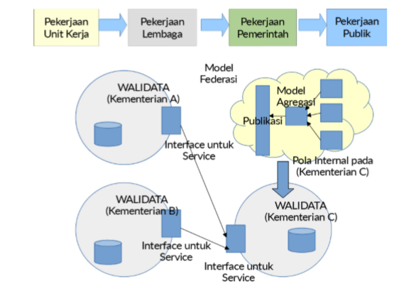

Figure 2.1: Data Owner

it depends on something in the PD DIKTI (Kemdikbud) because it is indeed the institution that plays the role of data o cer for the level of education. The use of heterogeneous information systems requires an information system to be interoperable. It forms an integrated system and can be used by a variety of organizations. Exchange of data and information in various forms becomes a challenge in forming an information system. It takes a central point in a hetero-geneous system to harmonize data and information. Heterogeneous information systems require integration in harmonizing the rate of exchange of data and information. Some types of integration in heterogeneous systems are as follows:

* **Presentation integration.** User interface that provides access to an application. The advantages of the presentation integration model are the risk and low cost, the available technology is relatively stable, easy to do, fast to implement, no need to change source data. While weaknesses exist in performance, perception, and the absence of interconnection between applications and data.
* **Data integration.** The data integration model is carried out directly on the database or data structure of the application by ignoring presentation and business logic when making integration. The advantage of the data integration model is that it is better than the presentation model and allows data to be used by other applications. However, if there is a change in the data model, then the integration needs to be revised or repeated.
* **Functional Integration.** The integration process is carried out at the level of business logic by utilizing distributed processing middleware. The advantage of functional integration lies in its strong integration capabilities among other integration models. In addition, the functional integration model uses true code reuse infrastructure for several applications in the enterprise. The PBE integration process is not only in the infrastructure and eGovernment applications but also in the eGovernment development budget. Thus, the focus of the eGovernment integration process will include integration as in Figure 2.2
* **Data integration.** put forward a data source that is OpenData. This means that the public can access all data through one portal. Basically, every institution.

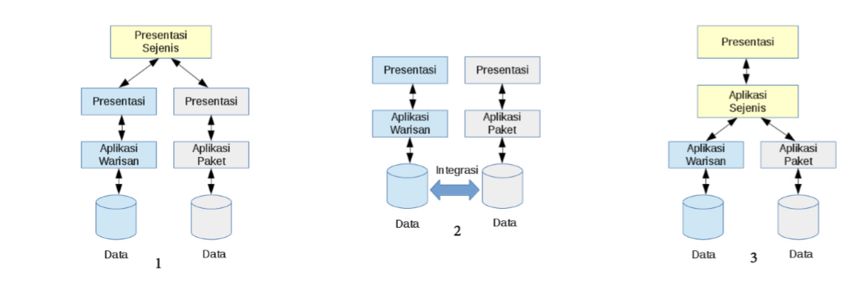

Figure 2.2: Integration type

which functions as data trustees will provide access to reference data, consolidate and validate data. Thus, various data sources that have various qualities, validations, bureaucratic structures and stages of updating data can be utilized appropriately.

* **Application integration**, making various eGovernment applications can exchange data even though they are created and operated by different parties. Interoperability can be maintained. Thus each application can exchange data without the need to duplicate the data entry process.
* **Service integration,** opening one door to business processes. This results in simplification of the process because it digitizes the manual, also changes the regulation due to the use of digital platforms.
* **Intervening governance**, arranging the authority that belongs to the central, regional and existing institutions. Governance must be carefully defined and supported by implementing human resources who have skills with certain standards. If this is done, even the process of integrating governance, both in terms of organization and human resources, is more easily achieved.
* **Budget integration,** aimed at minimizing budget duplication which is usually caused by the development of eGovernment based on organizational structure, not achievements and work programs. The budget is duplicated because it is implemented by a different structure.

Problems in heterogeneous information systems are information systems in each organization that cannot exchange data and information. Data interoperability will streamline work and can analyze AI-based information systems. The use of AI will support new knowledge and better decision making.

**2.2 Metadata Repository**

Metadata is simply defined in English as data about data, or data about data. This metadata is needed to describe all relevant aspects of the data warehouse. A simple example of metadata in the scope of database names. database location, table name, field name, and type. and so forth. Within the scope of the data warehouse in particular. There are three main types of metadata:

* Descriptive metadata describes a resource for a purpose such as discovery and identification. It can include elements such as title, abstract, author, and keyword.
* Structural metadata shows how a collection of objects are arranged together into one, such as how the pages are arranged to form a chapter.
* Administrative metadata provides information to help manage resources, such as when and how information is created, types of documents and other technical information, and who can access them.

Benefits of Metadata Publishing When classifying the benefits of publishing two groups of metadata is usually considered. External parties are usually consumers of information that are not part of the publishing organization. Internal parties are usually various business units or departments within an organization.

Benefits for external parties include:

* Enables external systems (both people and agents) to have a clear understanding of the semantics of data elements in a system.
* Enables third parties to construct semantic maps between data models and inter-system import and export data.
* Promote service-oriented architecture and allow horizontal information sharing between traditional information silos.
* Enables the system to participate in the search process that is indexed accurately and encrypted
* Benefits for internal parties include:
* Allow parties from diverse business units to agree on definitions of shared data and specific definitions of different departments or functions.
* Make Extract, transform, load (ETL) operations more appropriate for data warehousing.
* Enables the user interface designer to access common screen sets and header labels.
* Promotion of model-driven architecture

**2.3 Business Process Modelling Notation**

Business Process Modeling Notation (BPMN) describes a business process dia-gram that is which are based on owchart techniques, arranged to create graph-ical models from business operations where there are de ning activities and ow controls work order. BPMN was developed by a consortium of industries (BPMN.org), namely constituents representing various BPM tool vendors but not as a nal opening, said that "The Business Process Modeling Notation is Emerging as a standard language for capturing business process, e-specially at the level of domain analysis and high level systems design. The BPMN diagram consists of elements. This element is divided into four categories, namely:

* Flow Object,
* Connecting Object,
* Swimlanes, and
* artifact.

BPMN was initially developed by the Business Process Management Initiative (BPMI). BPMI released version 1.0 to the public in May 2004. In June 2005, BPMI joined Object Management Group (OMG). A BPMN Speci cation doc-ument was released by OMG in a month February 2006. Version 2.0 of BPMN was developed in 2010, and the actual version of these speci cations was released in December 2013. The latest version (2.0.2) has been published o cially by ISO as a 2013 edition Standard: ISO / IEC 19510.

**2.4 IDEF**

**2.4.1 idef definition**

IDEF (Integrated Definition) is a group of modeling methods that can be used to establish data models, business processes, and taxonomy of information [Ferry and Saputra, 2013]. IDEF methods are used to form modeling activities that support enterprise integration, where the first few methods are developed with the aim of improving communication among people who need to decide how the existing system is integrated, namely IDEF0, IDEF1, IDEF2, IDEF3, IDEF5 and IDEF6, while the second IDEF method group (IDEF7 - IDEF14) is focused on the design part of the system development process, including IDEF1X and IDEF methods as follows:

* IDEF0: Function Modeling (Analysis)
* IDEF1: Information Modeling (Analysis)
* IDEF1X: Data Modeling (Design)
* IDEF3: Process Modeling (Analysis and design)
* IDEF4: Object-Oriented Design (Design)
* IDEF5: Ontology Ontology Description Capture (Analysis)
* IDEF6: Design Rationale Capture
* IDEF7: Informaton System Audit Method 4
* IDEF8: Human-System Interaction Modeling
* IDEF9: Busness-Constraint Discovery Method (Analysis)
* IDEF10: Implementation Architecture Modeling
* IDEF11: Information Artifac Modeling
* IDEF12: Organizational Design Method
* IDEF13: 3-Schema Architecture Design Method
* IDEF14: Network / Distribution Design Method

**2.4.2 IDEF 0 Modeling Functions**

IDEF0 (Integration De nition language 0) is a method of modeling systems based on SADT (Structured Analysis and Design Technique), developed by Douglas T. Ross and SofTech, Inc. In its original form, IDEF0 includes language de nitions and graphical modeling (syntax and semantics) which describe a comprehensive methodology for building models [5]. IDEF0 can be used to model various types of systems, both automatic and non-automatic. For new systems, IDEF0 can be used to de ne requests and make function speci cations, and then be used to design and implement designs that suit your needs.

IDEF0 allows the user to describe a process viewpoint including (referring to ICOM):

* Input, i.e. resources that are consumed/transformed (re ned) by the pro-cess;
* Output, namely the things that are produced during the consumption/transformation of inputs by the process;
* Control, which is things that guide the process: policies, guidelines, stan-dards, laws;
* The Mechanism, which is an intermediary who completes actions (activi-ties) that limit the process.

**Characteristics of Idef 0:**

* Comprehensive and expressive, able to graphically represent various businesses, factories and other types of companies at every level of detail.
* The Language that is coherent and simple, provides precise and precise expressions and improves the consistency of use and interpretation
* Improve communication between system analysts, developers, and users through easy learning and detailed explanations in each part of the document.
* It has been tested and proven, through its many years of use in the air force and other government development projects, as well as industry.
* it can be generated from a variety of computer graphics tools; several commercial products specifically support the development and analysis of IDEF0 diagrams and models.

**Main Components**

The main components in IDEF0 are as follows:

* The box describes the main functions of the system. In this box, the function is usually written in the form of verbs.
* Arrows that indicate input (input data) are drawn from the left with the tip of the arrow going to the box that receives input.
* Arrows that indicate output (product) and are drawn from the right direction with the tip of the arrow showing other boxes (if any) or pointing to the right (if there are no / other functions that accept the output).
* The output of a function can be input to other functions.
* Arrows that indicate the controller/control of a function, depicted from the top with arrows entering the function. Control can be in the form of rules or operational control functions. Controls can also be output from other functions.

2.5 XSD

Extensible Markup Language (XML) is a markup language that is designed to be an easy means of sending documents through the Web. Unlike Hypertext Markup Language (HTML), XML allows users to de ne custom tags. However, the XML standard has no semantic constraints on the meaning of the document. XML emerged as the dominant standard for the representation and exchange of data through the Internet. XML has a nested structure and maps itself, this makes it easy for applications to model and exchange data. With so much data represented as XML documents, it becomes very necessary to store and query these XML documents. To overcome this problem, an XML database system has been built. XML emerged as the dominant standard for data representation and exchange via the Internet. XML has a nested structure and maps itself, this makes it easy for applications to model and exchange data. With so much data represented as XML documents, it becomes very necessary to store and query these XML documents. To overcome this problem, an XML database system has been built.

XML Schema Better known as XML Schema Definition (XSD) is an XML vocabulary that is used to express the rules (data definition) used in an XML data. Based on XSD, an XML document can be specified in detail of the structure and type of data. The background to the emergence of the concept and XML Schema is the dissatisfaction with DTD. DTD uses a different command that is Extended Backus Naur Form (EBNF) while XML documents use XML commands. The difference in the use of commands causes inconsistent data.

As a result the idea arose to make the definition of data used in XML data using XML commands. XSD is a development and DTD as a data definition and XML document. Based on the function and composition there are two types of XSD, namely flat and hierarchical schema. Flat schema is used to verify XML XML documents that are used to move and store data. Hierarchical schema is used to help facilitate the display of stored data. One of the biggest strengths of XML Schema is support for data types. With support for data types:

• It is easier to explain the contents of permitted documents

• Easier to validate data correctness

• It's easier to work with data from a database

• Easier to define aspects of data (data restrictions)

• Easier to define data patterns (data format)

• Easier to convert data between different data types

**Chapter 3**

**System Specification and Design**

**3.1 Stakeholder Analysis and User Model**

SH analisis (matrix)

USe Case dari MR

**3.1.1 Stakeholder Analysis(Matrix)**

Stakeholder Analysis is used as a process of identifying both individuals and groups who will in uence or be a ected by an action to be taken and group it according to the impact of the action to be taken. The information obtained can be used to conduct an evaluation before action is taken so that preventive e orts can be made by considering all parties involved. The table below is a Stakeholder Analysis of the Metadata Repository information system.

|  |  |  |  |  |  |  |  |
| --- | --- | --- | --- | --- | --- | --- | --- |
|  |  |  | Pemilik | BKN | SINKA |  | Publik |
|  |  |  |  |  |  |  |  |
|  | SIM A | | CRUD | R | R |  | R |
|  |  |  |  |  |  |  |  |
|  | DATABASE | |  |  |  |  |  |
|  |  |  |  |  |  |  |  |
| 1 |  | SAPK | CRUD | R | R |  | R |
|  |  |  |  |  |  |  |  |
|  | TABLE | |  |  |  |  |  |
|  |  |  |  |  |  |  |  |
| 1 |  | Table PNS | CRUD | R | R |  | R |
|  |  |  |  |  |  |  |  |
| 2 |  | Table Orang | CRUD | R | R |  | R |
|  |  |  |  |  |  |  |  |
| 3 |  | Table Angka | CRUD | R | R |  | R |
|  |  | Kredit |  |  |  |  |  |
|  |  |  |  |  |  |  |  |
| 4 |  | Table CLTN | CRUD | R | R |  | R |
|  |  |  |  |  |  |  |  |
| 5 |  | Table CPNS | CRUD | R | R |  | R |
|  |  |  |  |  |  |  |  |
| 6 |  | Table Diklat | CRUD | R | R |  | R |
|  |  | Struktural |  |  |  |  |  |
|  |  |  |  |  |  |  |  |
| 7 |  | Table RW | CRUD | R | R |  | R |
|  |  | Golongan |  |  |  |  |  |
|  |  |  |  |  |  |  |  |
| 8 |  | Table | CRUD | R | R |  | R |
|  |  | Hukdis |  |  |  |  |  |
|  |  |  |  |  |  |  |  |
| 9 |  | Table | CRUD | R | R |  | R |
|  |  | Jabatan |  |  |  |  |  |
|  |  |  |  |  |  |  |  |
| 10 |  | Table | CRUD | R | R |  | R |
|  |  | KedHuk |  |  |  |  |  |
|  |  |  |  |  |  |  |  |
| 11 |  | Table | CRUD | R | R |  | R |
|  |  | Keluarga |  |  |  |  |  |
|  |  |  |  |  |  |  |  |
| 12 |  | Table | CRUD | R | R |  | R |
|  |  | Kepanitiaan |  |  |  |  |  |
|  |  |  |  |  |  |  |  |
| 13 |  | Table RW | CRUD | R | R |  | R |
|  |  | Kursus |  |  |  |  |  |
|  |  |  |  |  |  |  |  |
| 14 |  | Table | CRUD | R | R |  | R |
|  |  | Organisasi |  |  |  |  |  |
|  |  |  |  |  |  |  |  |
| 15 |  | Table | CRUD | R | R |  | R |
|  |  | Pendidikan |  |  |  |  |  |
|  |  |  |  |  |  |  |  |
| 16 |  | Table | CRUD | R | R |  | R |
|  |  | Penghargaan |  |  |  |  |  |
|  |  |  |  |  |  |  |  |
| 17 |  | Table RW | CRUD | R | R |  | R |
|  |  | Pindah |  |  |  |  |  |
|  |  | Instansi |  |  |  |  |  |
|  |  |  |  |  |  |  |  |
| 18 |  | Table | CRUD | R | R |  | R |
|  |  | Prestasi |  |  |  |  |  |
|  |  |  |  |  |  |  |  |
| 19 |  | Table | CRUD | R | R |  | R |
|  |  | Profesi |  |  |  |  |  |
|  |  |  |  |  |  |  |  |
| 20 |  | Table PWK | CRUD | R | R |  | R |
|  |  |  |  |  |  |  |  |
| 21 |  | Table SKP | CRUD | R | R |  | R |
|  |  |  |  |  |  |  |  |
| 22 |  | Table RW | CRUD | R | R |  | R |
|  |  | Unor |  |  |  |  |  |
|  |  |  |  |  |  |  |  |

Table 3.1: Table Access Role

**3.1.2 User Case Metadata Repository**

Use case diagrams are used to explain communication between actors and systems in the form of diagram notation. The communication described will focus on what interactions can be carried out by the actors in the system. This writing uses a use case diagram in the form of diagram notation. Figure 3.1 shows the use case diagram from the Metadata Repository website

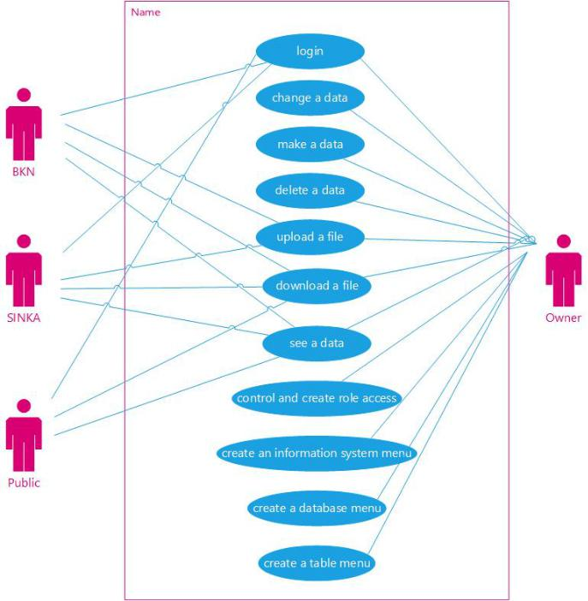

Figure 3.1: Table Access Role

## 3.2 Business Process

### 3.2.1 Implementation Stage

BPMN from MR-related processes

Implementation Stage The stages of implementing this procedure are as follows:

1. The Work Unit compiles the system adoption planning document. Planning documents the adoption of an electronic system was left to Sinka.
2. Sinka checks the completeness of the electronic system adoption planning document sent by the Work Unit. Planning documents have a minimum of:

(a) Requirement Analysis

(b) Business process modeling (BPMN)

(c) Budget plan

(d) Recommendations for implementation by the system owner

1. Sinka do an analysis:

(a) Technical Feasibility

(b) Legal Feasibility

(c) Operational Feasibility

(d) Eligibility Schedule

(e) Similarity to existing systems

1. Sinka provides system design recommendations in accordance with the analysis that has been done done
2. The Work Unit makes improvements to the electronic system adoption planning document in accordance with Sinka's recommendations
3. The Work Unit adopts the system with technical assistance from Sinka and system owner

**3.2.2 System Adoption Planning**

The stages described in section 3.2.1 above can be notated into BPMN as in Figure 3.2

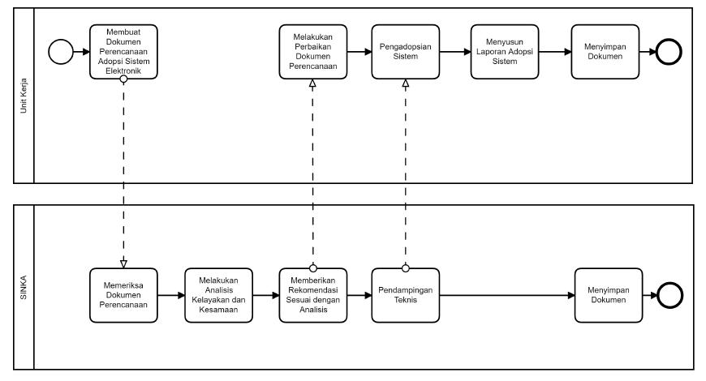

Figure 3.2: System Adoption Planning

## 3.3 Data Model

(IDEF 1, XSD dari data)

below is the xml schema definition (xsd) of the repository metadata application. There are 10 attributes, namely:

1. user
2. role
3. sim
4. database
5. table
6. isi table
7. download
8. sim roles
9. database roles
10. table roles

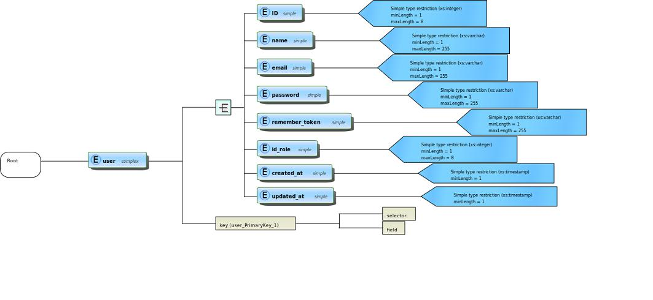

Figure 3.3: user-xsd

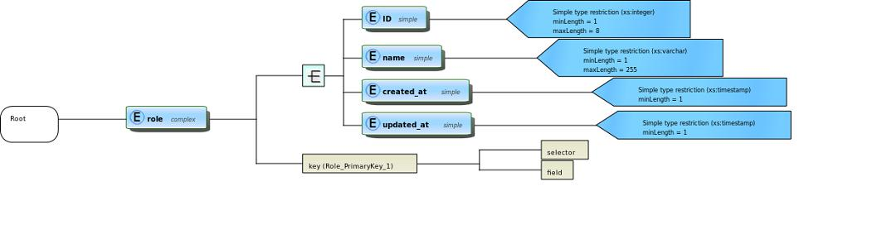

Figure 3.4: role-xsd

|  |  |
| --- | --- |
| CHAPTER 3. SYSTEM SPECIFICATION AND DESIGN | 23 |

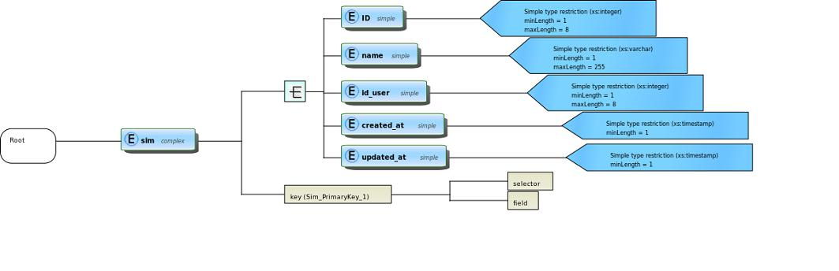

Figure 3.5: sim-xsd

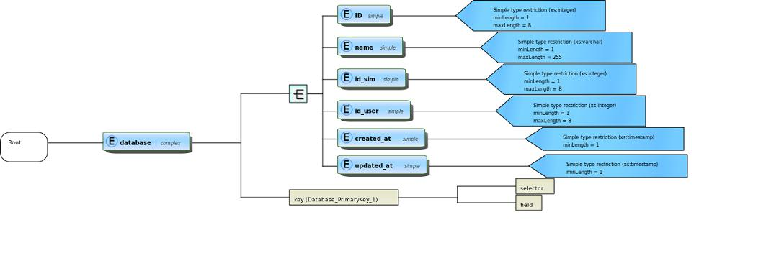

Figure 3.6: database-xsd

|  |  |
| --- | --- |
| CHAPTER 3. SYSTEM SPECIFICATION AND DESIGN | 24 |

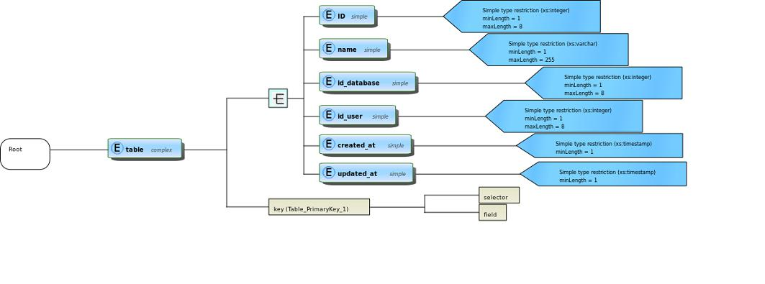

Figure 3.7: table-xsd

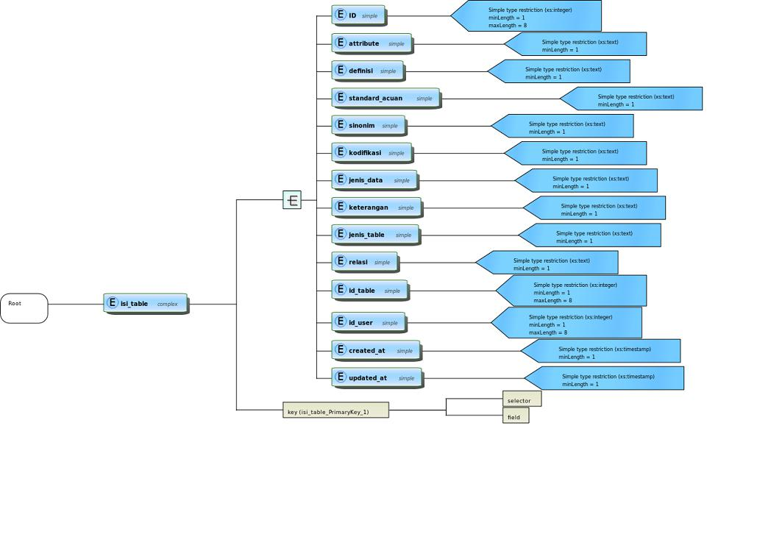

Figure 3.8: isi table-xsd

CHAPTER 3. SYSTEM SPECIFICATION AND DESIGN 26

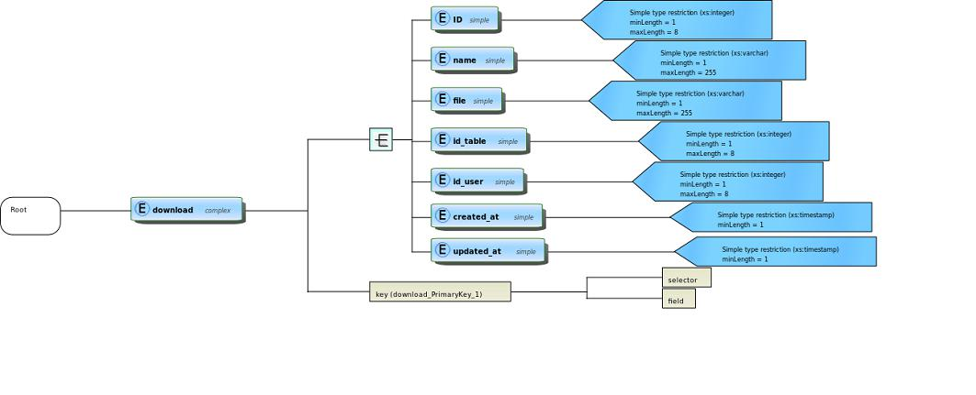

Figure 3.9: download-xsd

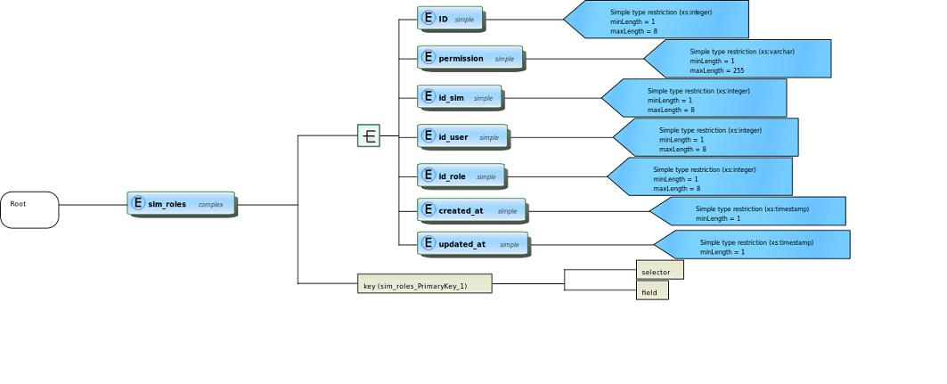

Figure 3.10: sim permission-xsd

CHAPTER 3. SYSTEM SPECIFICATION AND DESIGN 27

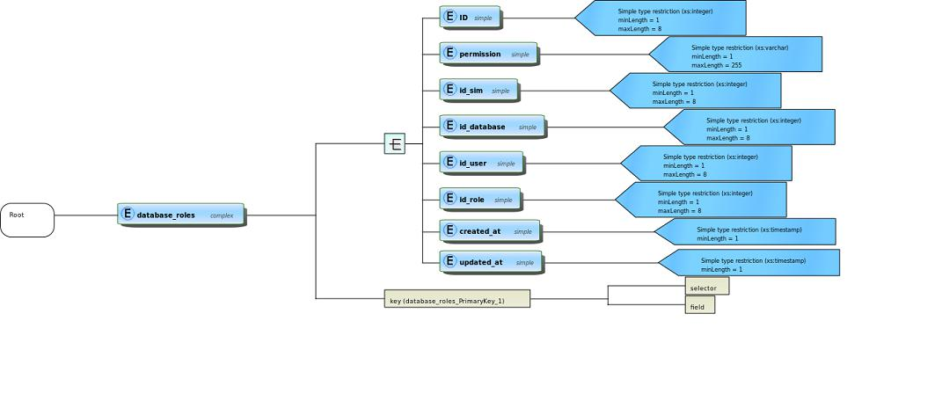

Figure 3.11: database permission-xsd

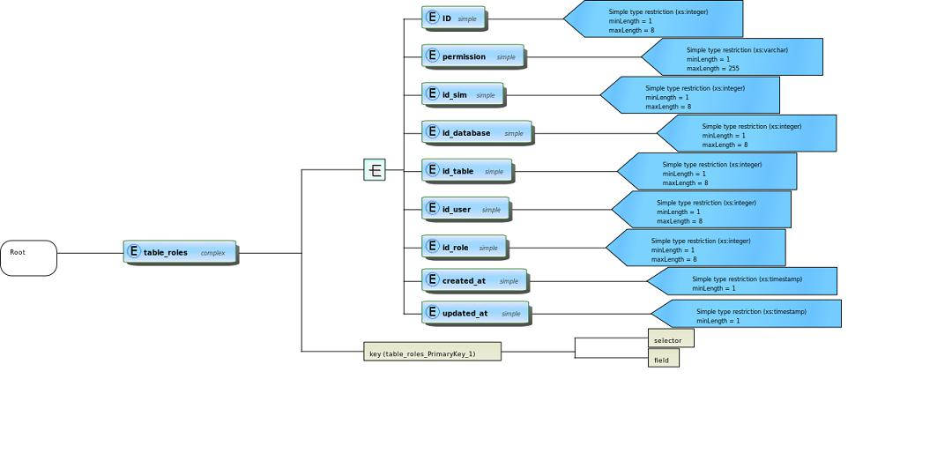

Figure 3.12: table permission-xsd

## 3.4 Fungsional Specification

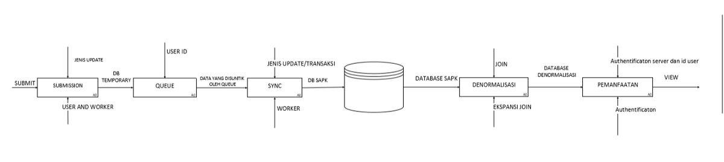

Gambar 3.13: IDEF 0

In the picture above there are 5 processes, namely the Submission process, the queue process, the sync process, the denormalization process, and the utilization process. in the first process, there is a submission process which is where there is input from submitting from the user then controlled by the type of update and produces a temporary database output, in this process the user and worker act as Mechanism. then in the second process, the Queue process, where the temporary database is inputted, controlled by the User Id, and produces output data injected by the queue. in the third process, there is a synchronization process that is data that is injected by the queue into input, controlled by the type of update/transaction and produces SAPK database output, this worker process acts as Mechanism. then furthermore the SAPK database is denormalized in the process of denormalization which is controlled by JOIN and produces a database output that has been normalized, in this process the joint expansion acts as Mechanism. and the last is the utilization process where the database which has been denominated as input, Authentication server and user id acts as the controller, Authentification acts as Mechanism, and produces output view.

**3.5 Interaction Specification**

User-flow story board

User flow is used to explain the steps that must be done by each user on the Metadata Repository website. Figure 3.14, shows the use flow from the Metadata Repository website.

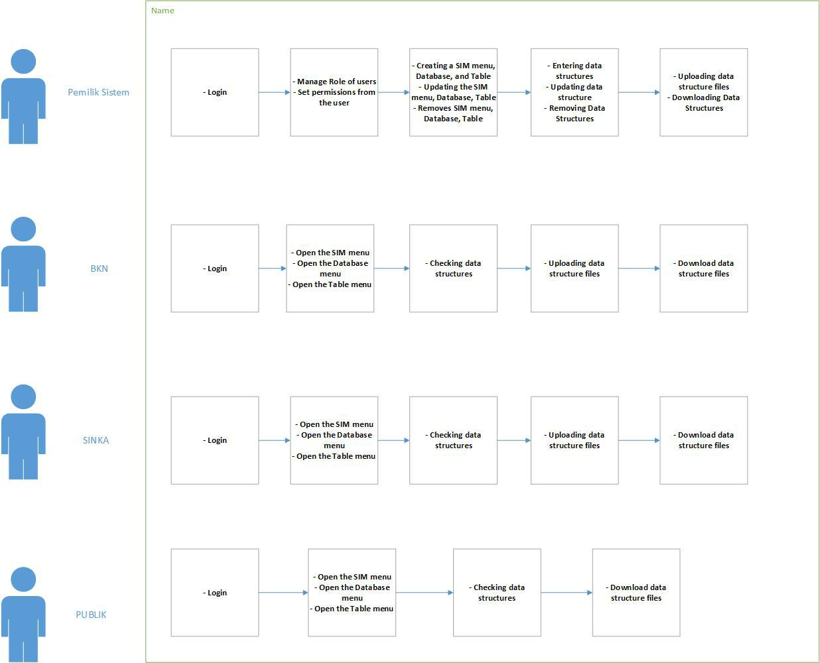

Figure 3.14: User-Flow

# **Chapter 4 Implementation**

## 4.1 System Design

Rancang bangun sistem (terutama dari posisi interoperabilitas)

At this point, the author will discuss the system design especially from the position of interoperability.

### 4.1.1 Login Mechanism

The image below is the design of the metadata repository application login page. the user must enter a username and password in order to enter the main page.

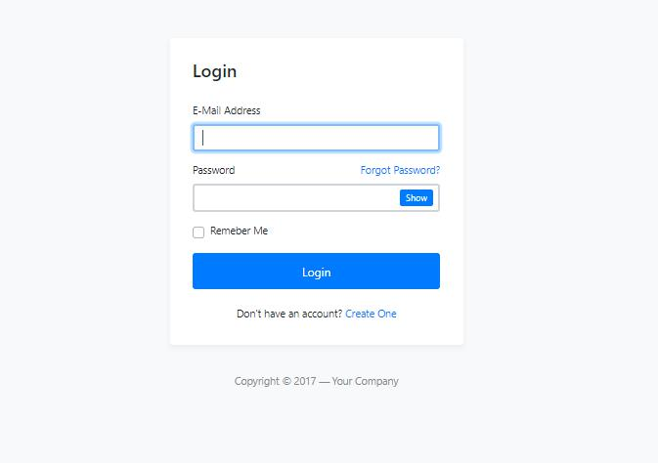

Figure 4.1: Login

**4.1.2 User Page**

The picture below is a user dashboard, where there is a list of users that contain user biodata registered in the repository metadata application.

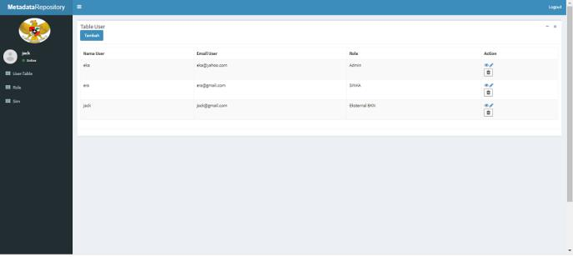

Figure 4.2: Dashboard table user

**4.1.3 Role Page**

The picture below is a dashboard role table, where there is a list of role names in the metadata repository application.

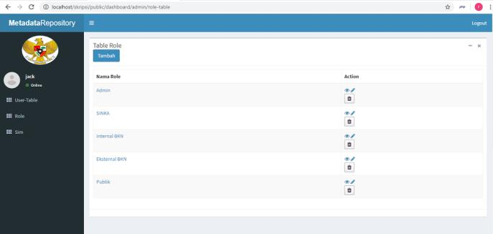

Figure 4.3: Dashboard table role

**4.1.4 SIM Page**

The picture below is a SIM page design, where there are lists of SIM names in the repository metadata application.

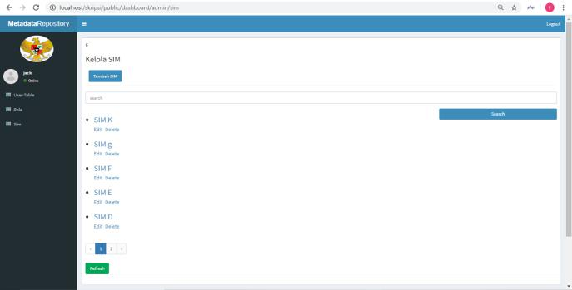

Figure 4.4: Sim Page

**4.1.5 Database Page**

The picture below is a database page design, where there are lists of database names in the metadata repository application.

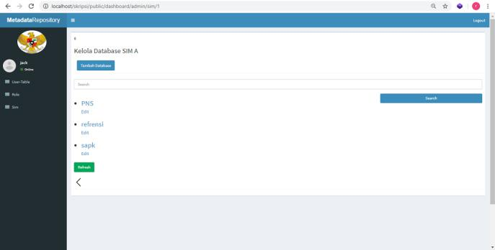



Figure 4.5: Database Page

**4.1.6 Table Page**

The picture below is a table page design, where there are lists of table names in the metadata repository application.

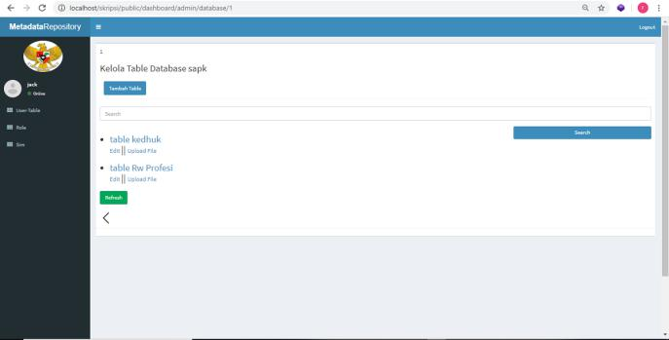

Figure 4.6: Table Page

**4.1.7 Access Page**

The picture below is an access table page design, where the admin can set any page that can be seen by the user in the repository metadata application.

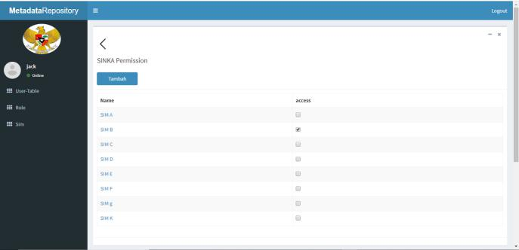

Figure 4.7: Access Page

**4.1.8 Data Structure Pages**

The picture below is the design of the data structure table page that the user can see and check, besides that the user can also download the data structure by clicking the download button.

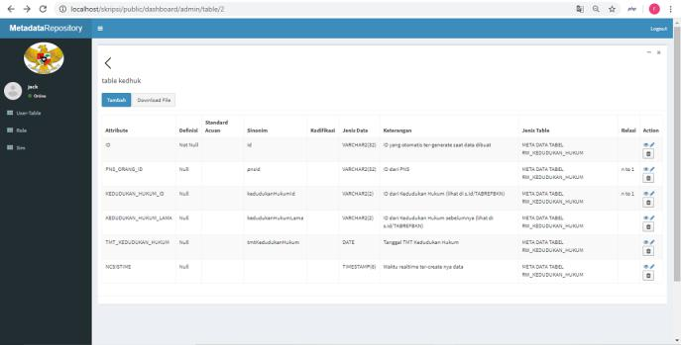

Figure 4.8: Data Structure Page

**4.1.9 File upload page**

below is the design page for uploading data structure les by the system owner to the metadata repository application.

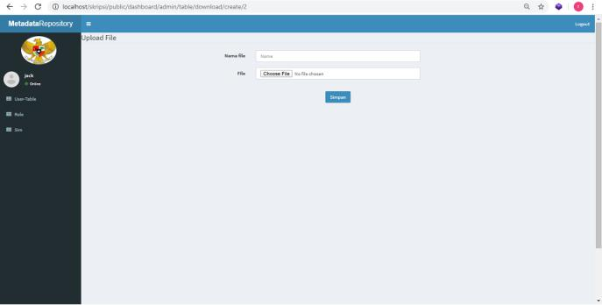

Figure 4.9: File Upload

**4.2 Technology implementation**

**4.2.1 Layering System**

to create a repository metadata application, there are several technologies used by the author, namely, from the server side the author uses apache, from the programming language the author uses php, css, and javascript, then from the framework the author uses laravel, and for the database the author uses Post-greeSql. for more details, as shown in Figure 4.10 below.

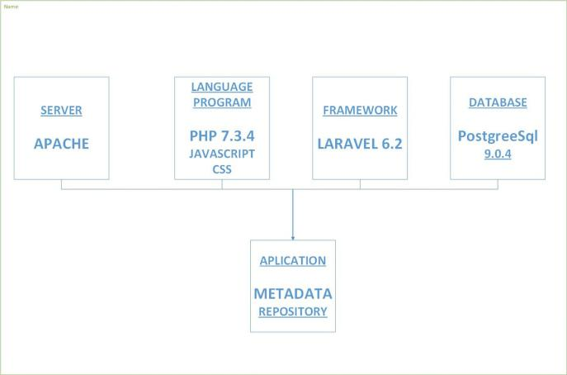

Figure 4.10: technology

**4.2.2 Snippet Code**

**4.2.2.1 Login Snippet Code**

snippet code Figure 4.11 below is a code from the login page in the view section of the metadata repository application.

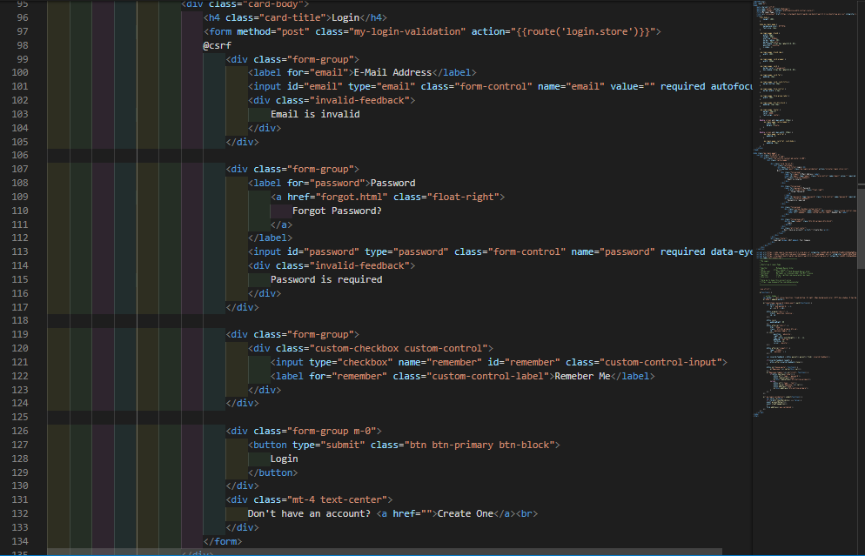

Figure 4.11: login-view

snippet code Figure 4.12 below is a code from the login page in the Controller section of the metadata repository application.

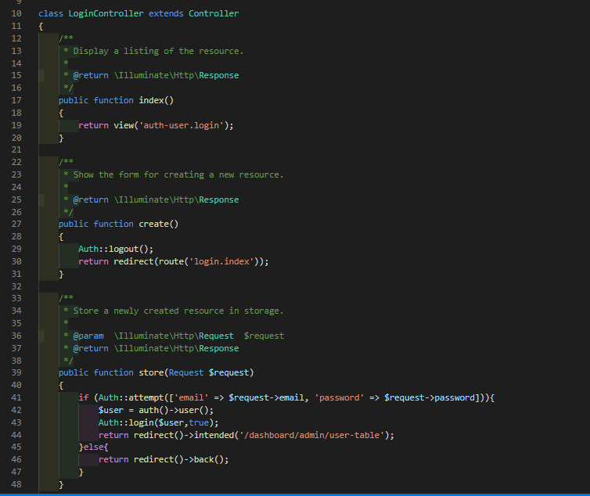

Figure 4.12: login-controller

**4.2.2.2 Structure Data Snippet Code**

snippet code Figure 4.13 below is a code for how to display the data structure in the view in the metadata repository application.

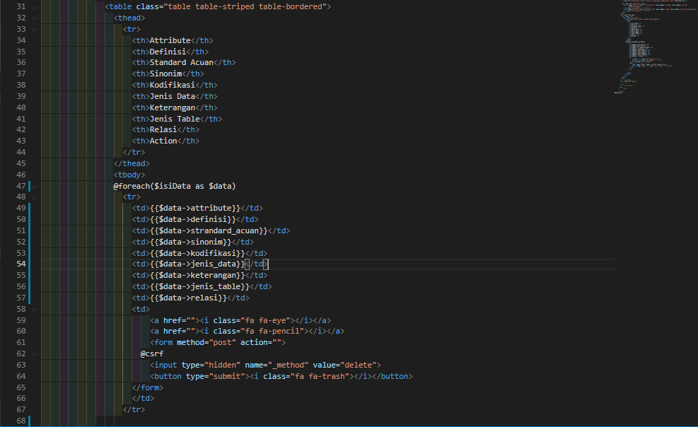

Figure 4.13: data-view

snippet code Figure 4.14 below is a code for how to display the data structure in the controller in the metadata repository application.

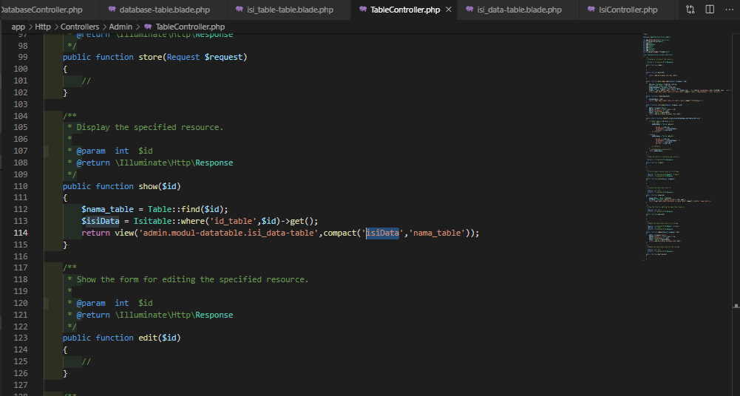

Figure 4.14: data-controller

## 4.3 Task and Interaction Implementation

Jelaskan Task yang ada dan menu yang terkait dan flow dari screen shot nya

### 4.3.1 Implementation of the Metadata Repository

To enable a better integration process, a Metadata Repository is implemented in the BKN environment. This Metadata Repository has the function of storing data definitions and other data description. So that is a form of a more complete data catalog. Use MR is as follows:

* Every information system manager in the BKN environment will include information about data managed into the system.
* Each system manager will enter information about,
  + SIM managed
  + Database used for each SIM
  + Tables in the database
  + The data in the table, along with information about the data, for example, type data, examples and so on.
* Each party that will access data for example for interoperability or data integration, then you can look to this Metadata Repository related to data definitions and information about that data
* Information about the data is provided in the form of Schema data, tables and graphical descriptions.

Each MR user will have different access to get information about definitive data is on BKN. Determination of the role's access via the menu as shown in Figure 4.15. Each system owner can be flexibly assigned access rights. Likewise each SIM owner can determine access rights as in Figure 4.16 Every MR user can see what SIMs are in the BKN environment. Presentation SIMs in the BKN are shown in Figure 4.17. In this way it is to find out and record which SIMs are managed in BKN can be more easily.

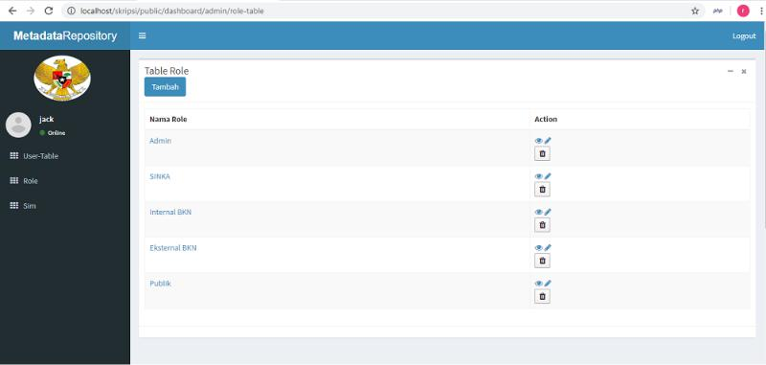

Figure 4.15: Table Access Role

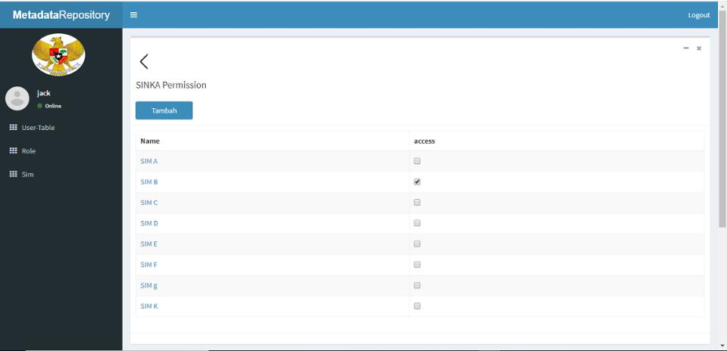

Figure 4.16: SIM access rights

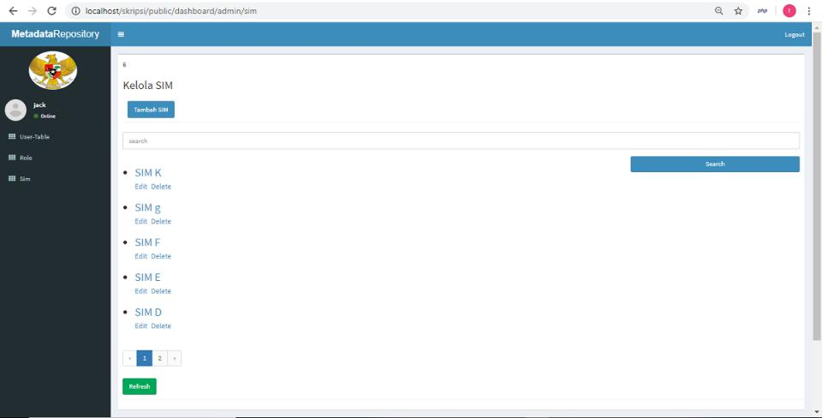

Figure 4.17: Show SIM menu

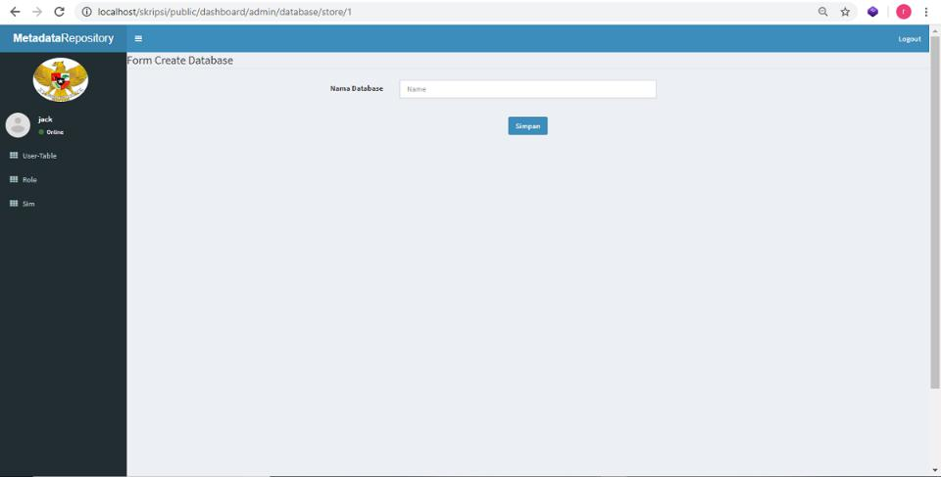

Figure 4.18: Form Create Database

with this if there are parties who need certain data, then the data is easily known on what SIM.

**4.3.2 How to register with MR**

When a work unit makes or has a SIM and will register with the MR This is done by using the SIM menu creation as shown in Figure 4.2.1. Written name SIM related. After a SIM is registered, it is necessary to register the databases on the SIM. For this, the menu is like the one in Figure 4.2.2 After the database is registered it needs to be set which party may know that there is The database is in the BKN environment. For this reason, the menu in Figure 4.2.3 is applied.

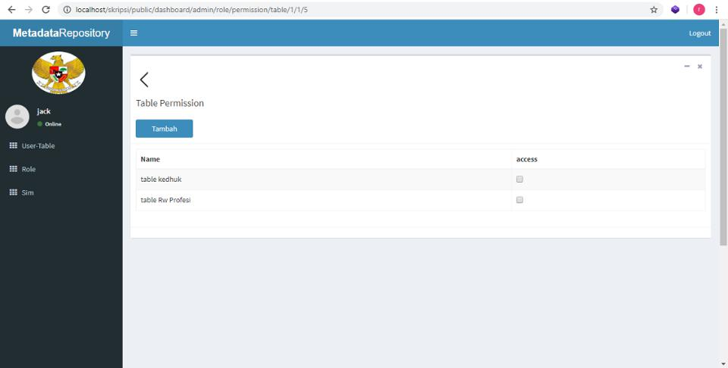

Figure 4.19: Table Permission

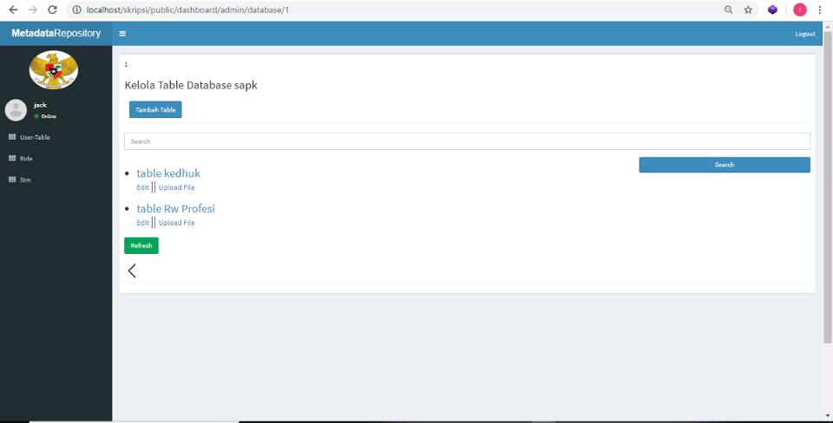

Figure 4.20: page table

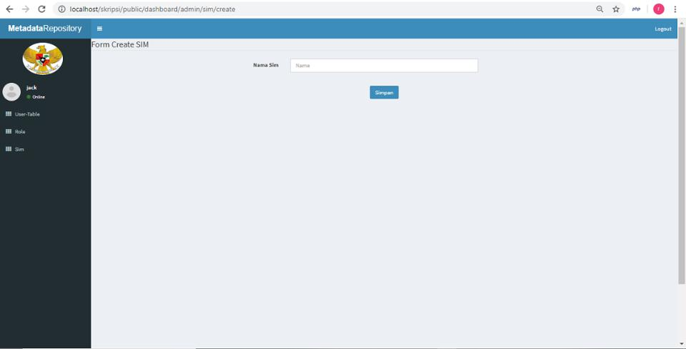

Figure 4.21: Register a new SIM

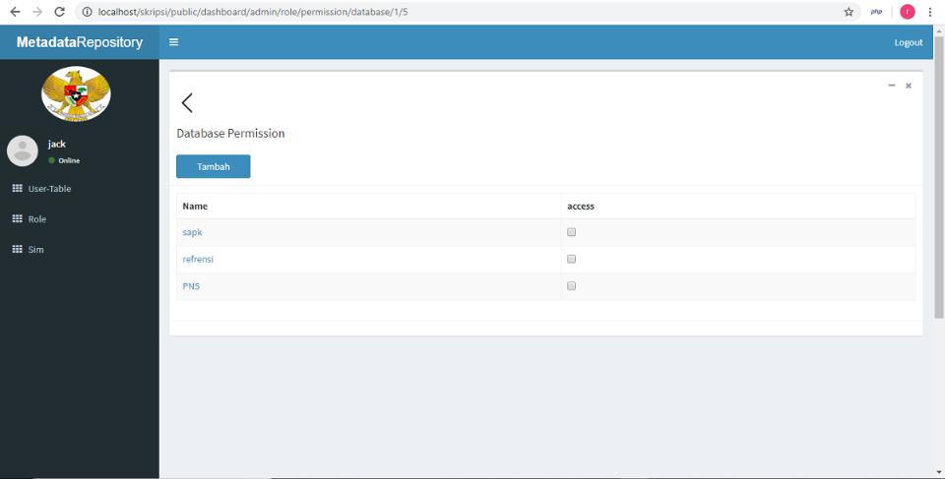

Figure 4.22: database permission table

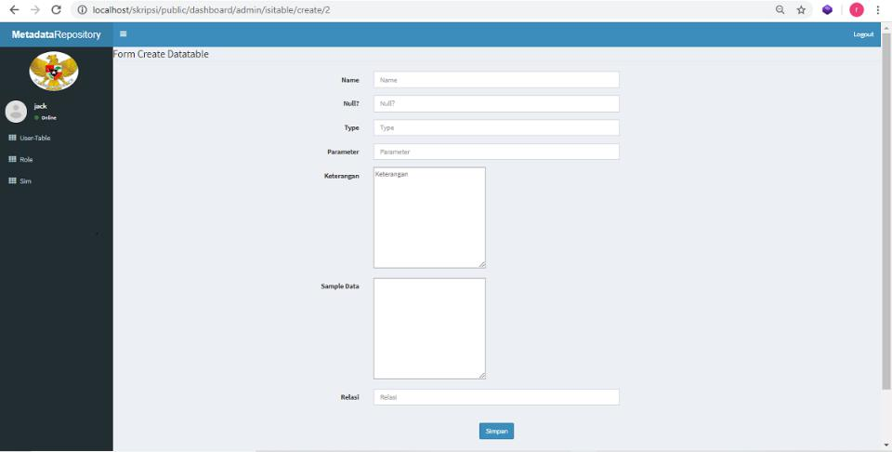

Figure 4.23: Registering Table

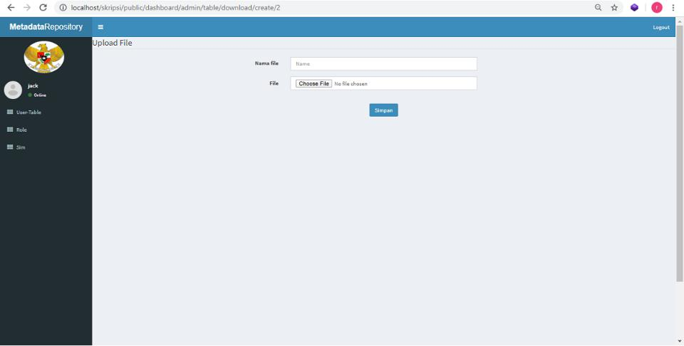

Figure 4.24: Upload Schema Definition File

Upload Schema Definition File After the SIM is registered, and the database is registered. Next is registering Table in the database. To register a table that is in a database is used menu as shown in Figure 4.2.3 Each data structure is provided both with tables, definitions in the form of data, and also XML Schema definition of the table. To upload XSD files and other definitions, then Use the menu shown in Figure 4.2.4.

**4.3.2 How to use the Metadata Repository**

After the SIM, database and table are entered into the MR statement, the external party and internal BKN can more easily nd out the data available in the BKN environment. Every people can access this information as shown in Figure 6.12. On the menu presented data de nitions, and other information. Data schema information can be downloaded.

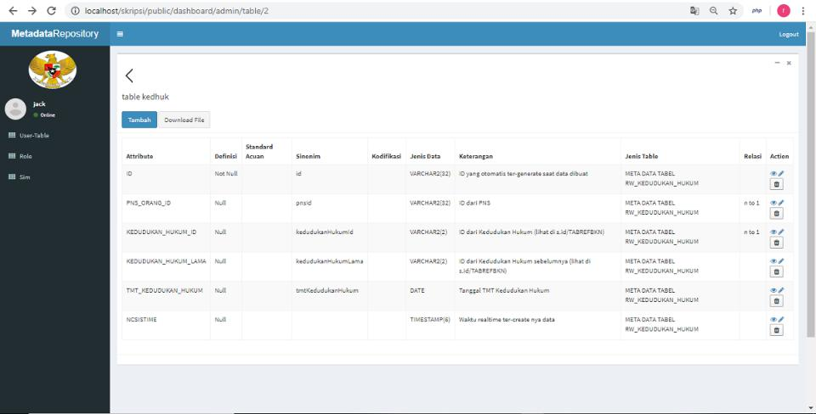

Figure 4.25: See Data Definition

# **Chapter 5 Evaluation and Discussion**

## 5.1 Testing Plan

The method used for testing the repository metada application is to use the MVC (Model View Controller) method with the laravel framework. A website needs to pay attention to the system that runs so that users can understand it easily. Therefore, system interaction with users needs to be tested to ensure that the website is designed to function properly.

### 5.1.1 Trial Adding Metadata

Following are the test steps to add metadata to the repository metadata application:

1. Select the SIM Menu
2. Choosing a sim that matches the metadata location.
3. Select a database that matches the location of the metadata.
4. Select a table that matches the location of the metadata.
5. pressing the create data button.
6. pressing the save button when completing the form.

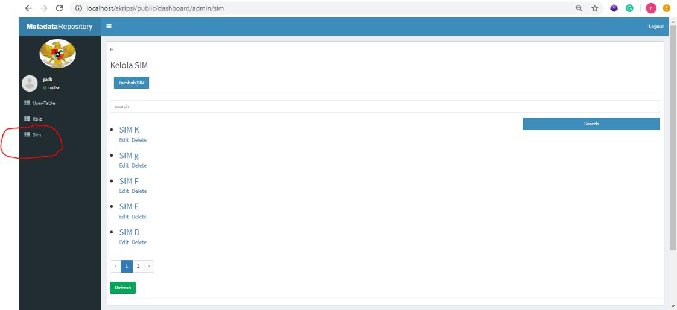

Figure 5.1: step 1

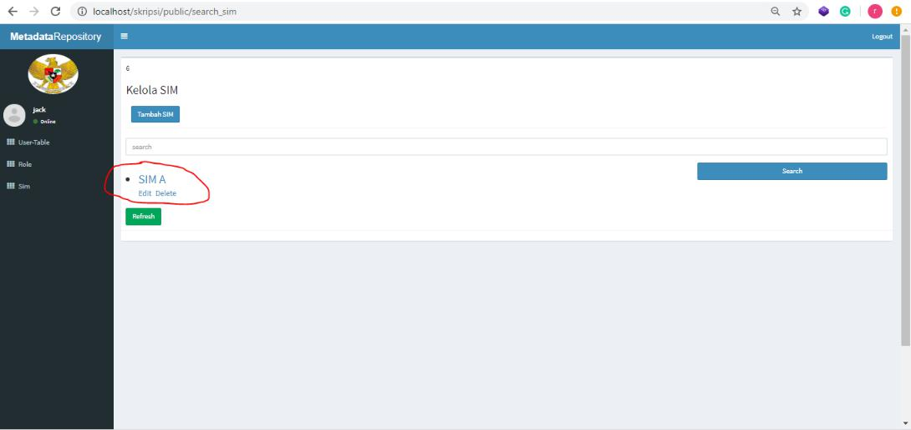

Figure 5.2: step 2

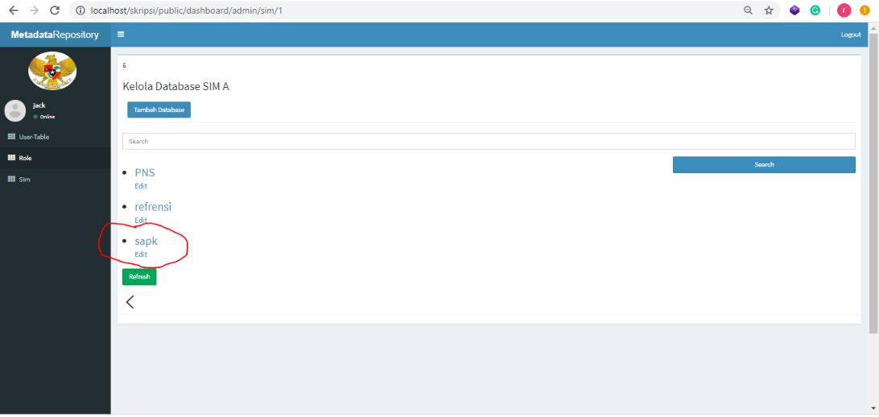

Figure 5.3: step 3

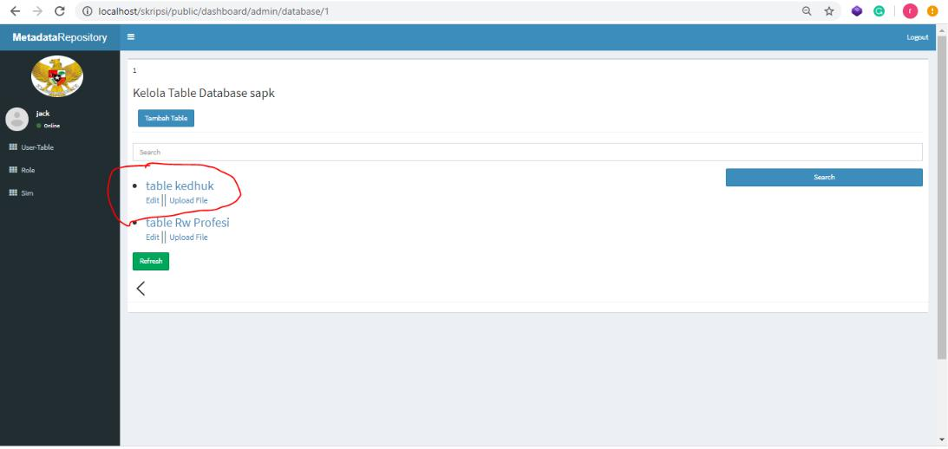

Figure 5.4: step 4

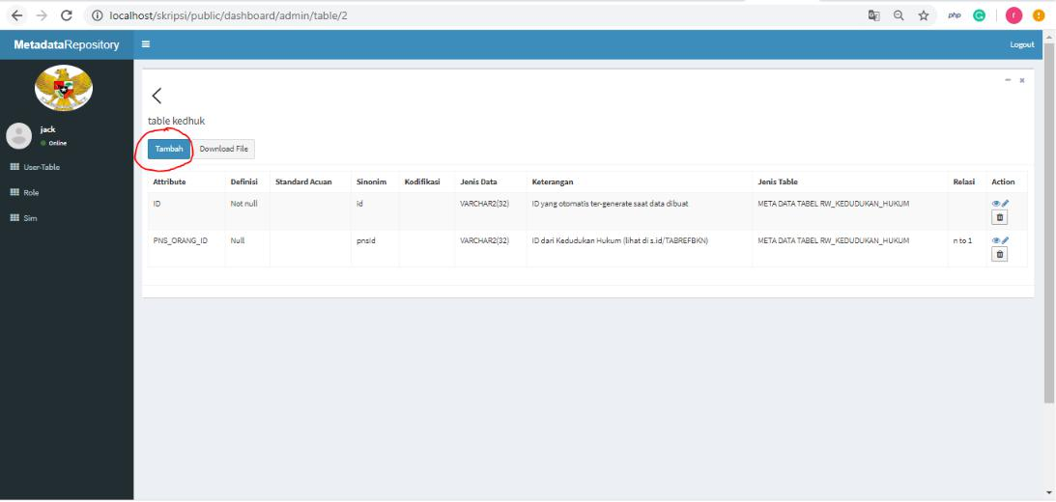

Figure 5.5: step 5

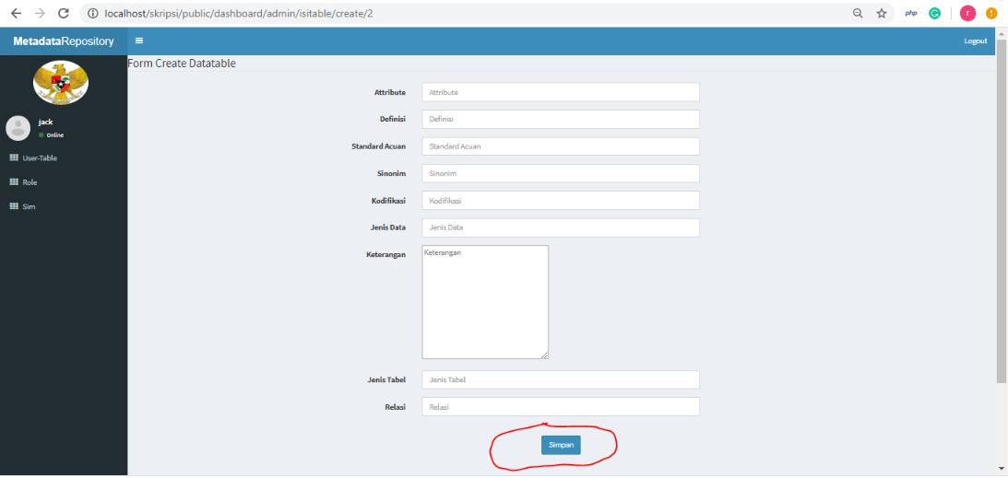

Figure 5.6: step 6

**5.1.2 Trial Viewing Metadata**

The following are the test steps for viewing metadata in the repository metadata application:

* + - 1. Select the SIM Menu
      2. Choosing a sim that matches the metadata location.
      3. Select a database that matches the location of the metadata.
      4. Select a table that matches the location of the metadata.



Figure 5.7: step 1



Figure 5.8: step 2



Figure 5.9: step 3



Figure 5.10: step 4

### 5.1.3 Trial Downloading Metadata

Following are the testing steps for downloading metadata in the repository metadata application:

1. Select the SIM Menu
2. Choosing a sim that matches the metadata location.
3. Select a database that matches the location of the metadata.
4. Select a table that matches the location of the metadata.
5. pressing the Download button.



Figure 5.11: step 1



Figure 5.12: step 2



Figure 5.13: step 3



Figure 5.14: step 4

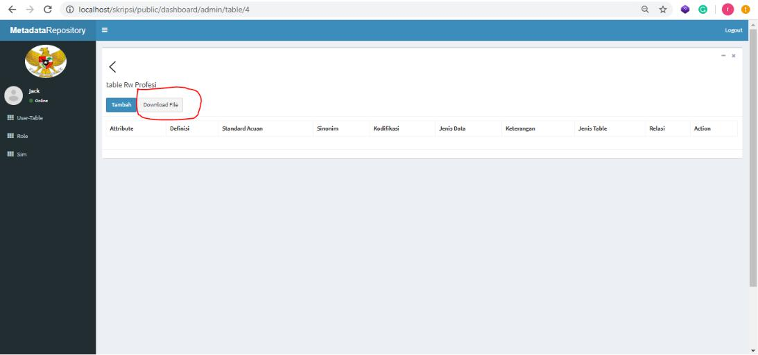

Figure 5.15: step 5

**5.2 Testing Result**

**5.2.1 Trial Results Adding Metadata**

From the results of trials adding data to the repository metadata application. It can be concluded, that the trial of adding data was successful as shown in Figure 5.16 below:

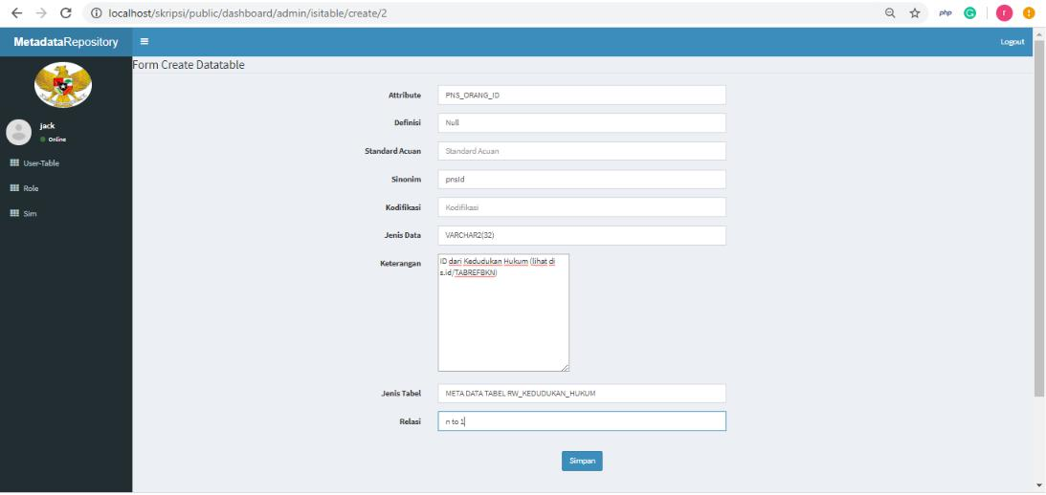

Figure 5.16: Trial Results Adding Metadata



Figure 5.17: Trial Results Adding Metadata2

**5.2.2 Trial Results See Metadata**

From the results of the trial see the data in the repository metadata application.

It can be concluded, that the trial saw successful data like Figure 5.18:



Figure 5.18: Trial Results See Metadata

**5.2.3 Trial Results Download Metadata**

From the results of the trial download the data in the repository metadata ap-plication. It can be concluded, that the trial download of the data was successful as Figure 5.19:

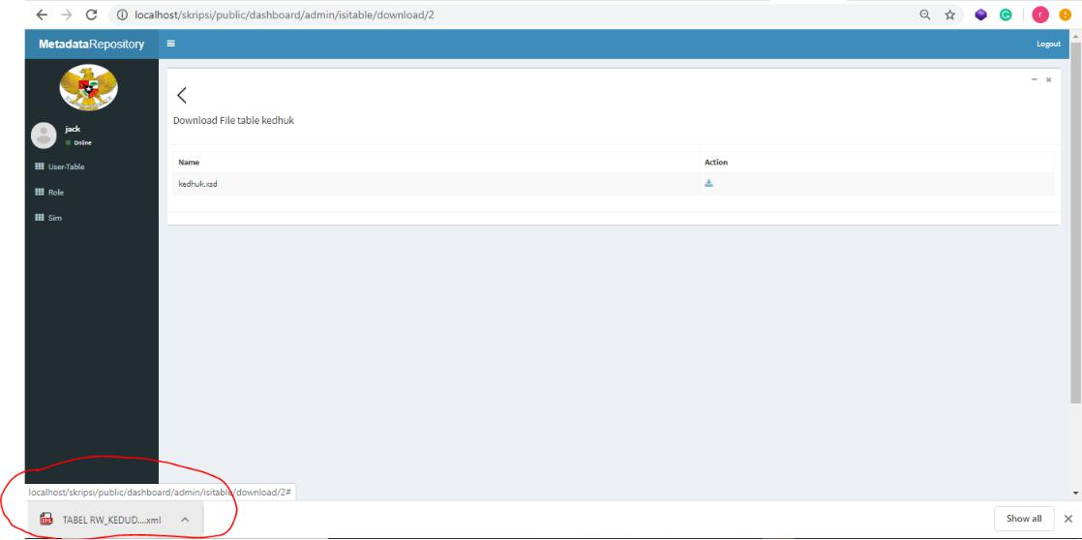

Figure 5.19: Trial Results Download Metadata

**5.3 Discussion**

Diskusi

**Chapter 6**

**Conclusion**

Berdasarkan hasil penelitian, maka ditunjukkan bahwa:

1. Berhasil membuat aplikasi metadata repository guna:
   * memastikan keamanan dan memudahkan pengelolaan data dari be-ragam sumber
   * pihak internal dan eksternal dapat mengetahui data yang dimiliki oleh BKN dan lokasi penyimpanan data pada sistem informasi
   * membantu proses permodelan data untuk kebutuhan integrasi
2. Berhasil memodelkan data pada aplikasi saat ini dengan menggunakan XML Schema De nition
3. Berhasil membuat Idef 0 menganalisis fungsi yang dilaksanakan sistem BKN dan mencatat mekanisme dari fungsi tersebut.